

SC2006 Software Engineering
Lab 4 Deliverables
Tutorial Group : SCE2

Name | Matriculation Number
Andy Thiang | U2422050E
Dinh Quang Anh | U2420664J
Chew Hong Ming | U2421627D
Justin Tan Shao Yang | U2420728L
Benjamin Phang Qi Lun | U2421150K
Caasi John Rian Domingo | U2422794F

1. Black Box Testing 3
I. AuthController 3
II. InputController 3
III. SaveItineraryController 3
IV. Black Box testing techniques 3
V. Test Cases and Results 4
2. White Box Testing 9
1. Login 9
1.1 Control Flow Graph 9
1.2 Basic Path Testing 9
1.3 Test Cases and Results 10
2. Validate Location 12
2.1 Control Flow Graph 12
2.2 Basic Path Testing 13
2.3 Test Cases and Results 13

1. Black Box Testing

AuthController
The AuthController class manages user login, user registration and password reset within the app.

InputController
The InputController class manages Location Validation and the Search Location Auto-Suggest feature of the app.

SaveItineraryController
The SaveItineraryController manages the Save Route feature of the app.

Black Box testing techniques
Equivalence Class Testing
The main idea is to divide all possible input data into a few groups, or "classes," where the system is expected to behave similarly for all inputs within the same class.
Instead of testing every single possible input (which is often impossible), you just pick one representative value from each class. The assumption is: if it works for one, it will work for all others in that class.

Boundary Value Testing

This technique is a natural next step after Equivalence Class Testing. It's based on the common experience that many bugs are found right at the edges or "boundaries" of the input ranges.

Test Cases and Results
- Login
Input Parameters: Email, Password

No. | Test Input | Expected Output | Actual Output | Pass?
1 | (Valid) Email : “user1@gmail.com”  (Valid) Password : “Password” | Successful login | Successful login | Yes
2 | (Invalid) Email : “ “  (Valid) Password : “Password” | Login failed, system notify “invalid login credentials, please try again” | Login failed, system notify “invalid login credentials, please try again” | Yes
3 | (Valid) Email : “user1@gmail.com”  (Invalid) Password : “ ” | Login failed, system notify “invalid login credentials, please try again” | Login failed, system notify “invalid login credentials, please try again” | Yes
4 | (Invalid) Email : “user1“  (Valid) Password : “Password” | Login failed, system notify “invalid login credentials, please try again” | Login failed, system notify “invalid login credentials, please try again” | Yes
5 | (Valid) Email : “user1@gmail.com”  (Invalid) Password : “Pass” | Login failed, system notify “invalid login credentials, please try again” | Login failed, system notify “invalid login credentials, please try again” | Yes

- Register
Input Parameters: First Name, Last Name, Email, Address, Contact Number, Password, Confirm Password

No. | Test Input | Expected Output | Actual Output | Pass?
1 | (All valid inputs)  First Name : “Xiao”  Last Name : “Ming”  Email : “user1@gmail.com”  Address : “ 50 Nanyang Ave, Singapore 639798 “  Contact Number : “99996666”  Password : “Password@1”  Confirm Password : “Password@1” | Successful signup | Successful signup | Yes
2 | (All Valid Inputs except First Name)  First Name : “ “ | System Notify “ Please input all fields.” | System Notify “ Please input all fields.” | Yes
3 | (All Valid Inputs except Last Name)  Last Name : “ “ | System Notify “ Please input all fields.” | System Notify “ Please input all fields.” | Yes
4 | (All Valid Inputs except Email)  Email : “ “ | System Notify “ Please input all fields.” | System Notify “ Please input all fields.” | Yes
5 | (All Valid Inputs except Address)  Address : “ “ | System Notify “ Please input all fields.” | System Notify “ Please input all fields.” | Yes
6 | (All Valid Inputs except Contact Number)  Contact Number : “ “ | System Notify “ Please input all fields.” | System Notify “ Please input all fields.” | Yes
7 | (All Valid Inputs except Password)  Password : “ “ | System Notify “ Please input all fields.” | System Notify “ Please input all fields.” | Yes
8 | (All Valid Inputs except Password)  Password : “pass“ | System Notify “ Password must be at least 8 characters” | System Notify “ Password must be at least 8 characters” | Yes
9 | (All Valid Inputs except Password)  Password : “password1“ | System Notify “ Password must include at least 1 special character” | System Notify “ Password must include at least 1 special character” | Yes
10 | (All Valid Inputs except Password)  Password : “password@“ | System Notify “ Password must include at least 1 numerical digit ” | System Notify “ Password must include at least 1 numerical digit ” | Yes
11 | (All Valid Inputs except Confirm Password)  Confirm Password : “ “ | System Notify “ Please input all fields.” | System Notify “ Please input all fields.” | Yes
12 | (All Valid Inputs except Confirm Password)  Password “ Password@1 ”  Confirm Password : “ Password “ | System Notify “ Password and Confirm Password must match” | System Notify “ Password and Confirm Password must match” | Yes

- Password Reset
Input Parameters: New Password, Confirm New Password

No. | Test Input | Expected Output | Actual Output | Pass?
1 | (Valid) Password : “Password@2”  (Valid) Confirm Password : “Password@2” | Successful Reset | Successful Reset | Yes
2 | (Invalid) Password : “ ”  (Invalid) Confirm Password : “ ” | Reset failed, system notify “Please input all fields” | Reset failed, system notify “Please input all fields” | Yes
3 | (Invalid) Password : “ ”  (Valid) Confirm Password : “Password@2” | Reset failed, system notify “Please input all fields” | Reset failed, system notify “Please input all fields” | Yes
4 | (Valid) Password : “Password@2”  (Invalid) Confirm Password : “ ” | Reset failed, system notify “Please input all fields” | Reset failed, system notify “Please input all fields” | Yes
5 | (Valid) Password : “Password@2”  (Invalid) Confirm Password : “Password@1 ” | System Notify “ Password and Confirm Password must match” | System Notify “ Password and Confirm Password must match” | Yes
6 | (Invalid) Password : “pass“ | System Notify “ Password must be at least 8 characters” | System Notify “ Password must be at least 8 characters” | Yes
7 | (Invalid) Password : “password1 | System Notify “ Password must include at least 1 special character” | System Notify “ Password must include at least 1 special character” | Yes
8 | (Invalid) Password : “password@“ | System Notify “ Password must include at least 1 numerical digit ” | System Notify “ Password must include at least 1 numerical digit ” | Yes

- Validate Location
Input Parameters: Start Location, End Location

No. | Test Input | Expected Output | Actual Output | Pass?
1 | (Valid) Start Location : “50 Nanyang Ave, Singapore 639798”  (Valid) End Location : “ 301 Boon Lay Wy, Singapore 649846” | Location Validation  Successful | Location Validation  Successful | Yes
2 | (Valid) Start Location : “50 Nanyang Ave, Singapore 639798”  (Invalid) End Location : “ ” | System Notify “Invalid location. Please enter a valid Singapore location and try again.” | System Notify “Invalid location. Please enter a valid Singapore location and try again.” | Yes
3 | (Invalid) Start Location : “ ”  (Valid) End Location : “ 301 Boon Lay Wy, Singapore 649846” | System Notify “Invalid location. Please enter a valid Singapore location and try again.” | System Notify “Invalid location. Please enter a valid Singapore location and try again.” | Yes
4 | (Invalid) Start Location : “ ”  (Invalid) End Location : “ ” | System Notify “Invalid location. Please enter a valid Singapore location and try again.” | System Notify “Invalid location. Please enter a valid Singapore location and try again.” | Yes
5 | (Valid) Start Location : “50 Nanyang Ave, Singapore 639798”  (Invalid) End Location : “Ochard” | End Location = "Orchard Road”  Location Validation  Successful | End Location = "Orchard Road”  Location Validation  Successful | Yes
6 | (Invalid) Start Location : “Ochard”  (Valid) End Location : “ 301 Boon Lay Wy, Singapore 649846” | Start Location = "Orchard Road”  Location Validation  Successful | Start Location = "Orchard Road”  Location Validation  Successful | Yes

- Search Location Auto-Suggest
Input Parameters: Start Location, End Location

No. | Test Input | Expected Output | Actual Output | Pass?
1 | (Valid) Start Location : “Ochard” | Dropdown below Start Location search bar "Orchard Road, Orchard Road Plaza Singapura, Orchard Central” | Dropdown below Start Location search bar "Orchard Road, Orchard Road Plaza Singapura, Orchard Central” | Yes
2 | (Valid) End Location : “Ochard” | Dropdown below End Location search bar "Orchard Road, Orchard Road Plaza Singapura, Orchard Central” | Dropdown below End Location search bar "Orchard Road, Orchard Road Plaza Singapura, Orchard Central” | Yes
3 | (Invalid) Start Location : “!@#“ | Dropdown below Start Location search bar will be Empty | Dropdown below Start Location search bar will be Empty | Yes
4 | (Invalid) End Location: “!@#“ | Dropdown below End Location search bar will be Empty | Dropdown below End Location search bar will be Empty | Yes

- Saved Route
Input Parameters: Save Itinerary Button

No. | Test Input | Expected Output | Actual Output | Pass?
1 | (Valid) Save Itinerary Button == True  (Valid) User is logged in | Itinerary Successfully saved | Itinerary Successfully saved | Yes
2 | (Valid) Save Itinerary Button == True  (Invalid) User is not logged in | Login Prompt will appear | Login Prompt will appear | Yes

2. White Box Testing

Login

1.1 Control Flow Graph

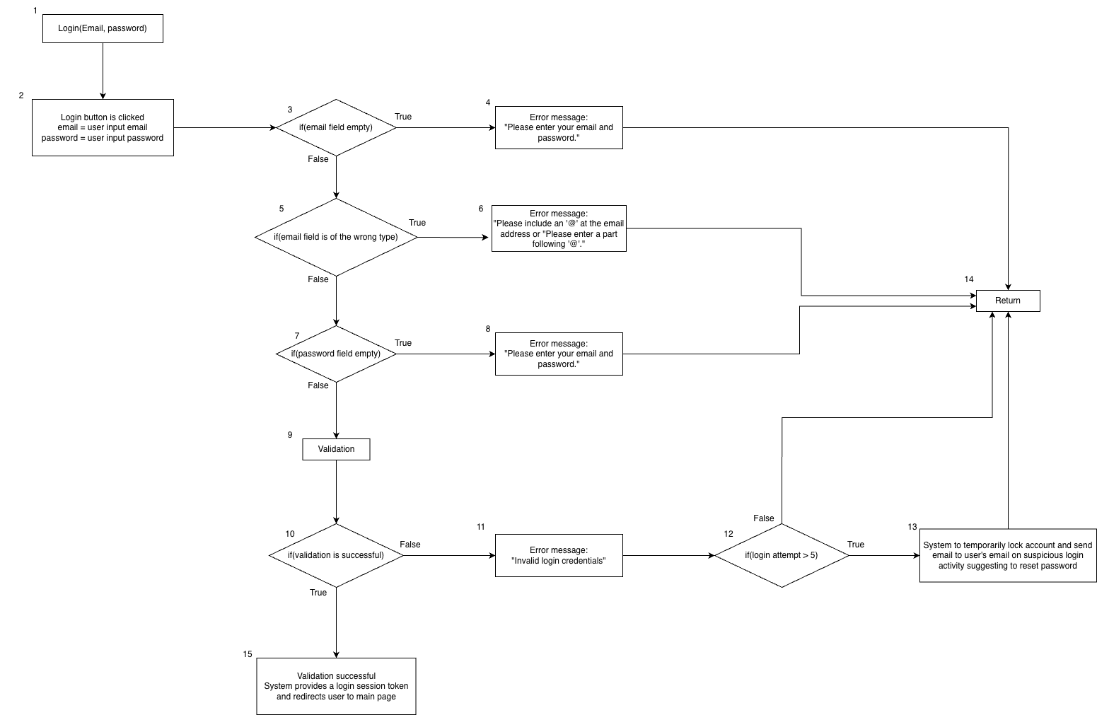

1.2 Basic Path Testing

Cyclomatic Complexity = | decision points | + 1 = 5 + 1 = 6

Basis paths

- Baseline Path: 1, 2, 3, 5, 7, 9, 10, 15
- Basis Path 1: 1, 2, 3, 4, 14
- Basis Path 2: 1, 2, 3, 5, 6, 14
- Basis Path 3: 1, 2, 3, 5, 7, 8, 14
- Basis Path 4: 1, 2, 3, 5, 7, 9, 10, 11, 12, 14
- Basis Path 5: 1, 2, 3, 5, 7, 9, 10, 11, 12, 13, 14

Explanation of basis paths
Baseline Path: User to input login credentials and clicks the login button. System checks for empty email or password fields. No empty fields detected, system to check and validate account details in accordance to input and validation. Validation is successful and brings the user to the main page.

Path 1: User to input login credentials and clicks the login button. System checks and detects empty email field. System to display error message to prompt user to fill in email field. Returns the user to the login page.

Path 2: User to input login credentials and clicks the login button. System checks and detects the email field is of the wrong type. System to display error message to prompt user to check and re-enter email field. Returns the user to the login page.

Path 3: User to input login credentials and clicks the login button. System checks and detects the password field is empty. System to display error message to prompt user to fill in password field. Returns the user to the login page.

Path 4: User to input login credentials and clicks the login button. System checks for empty email or password fields. No empty fields detected, system to check and validate account details in accordance to input and validation. Validation is unsuccessful, system to return user to login page if login attempt is less than 5 times.

Path 5: User to input login credentials and clicks the login button. System checks for empty email or password fields. No empty fields detected, system to check and validate account details in accordance to input and validation. Validation is unsuccessful and login attempt is more than 5 times, system to temporarily lock account and email user on suspicious activity suggesting to reset password.

1.3 Test Cases and Results

Login(Email, Password)
No. | Test Input | Expected Output | Actual Output | Pass?
Baseline | Email = “Admin1@gmail.com”  Password = “12341234!” | “Log in successfully” | “Log in successfully” | Yes
1 | Email = “”  Password = “12341234!” | “Please enter your email and password!” | “Please enter your email and password!” | Yes
2 | Email = “Admin1”  Password = “12341234!” | “Please include an ‘@’ at the email address.” | “Please include an ‘@’ at the email address.” | Yes
3 | Email = “Admin1@”  Password = “12341234!” | “Please enter a part following ‘@’.” | “Please enter a part following ‘@’.” | Yes
4 | Email = “Admin1@gmail.com”  Password = “” | “Please enter your email and password!” | “Please enter your email and password!” | Yes
5 | Email = “someone1@gmail.com”  Password = “12341234!” | “Invalid login Credentials” | “Invalid login Credentials” | Yes
6 | (5th Attempt incorrect)  Email = “someone1@gmail.com”  Password = “12341234!” | “Account is locked, please check your email to reset your password~” | “Account is locked, please check your email to reset your password~” | Yes

Validate Location

2.1 Control Flow Graph
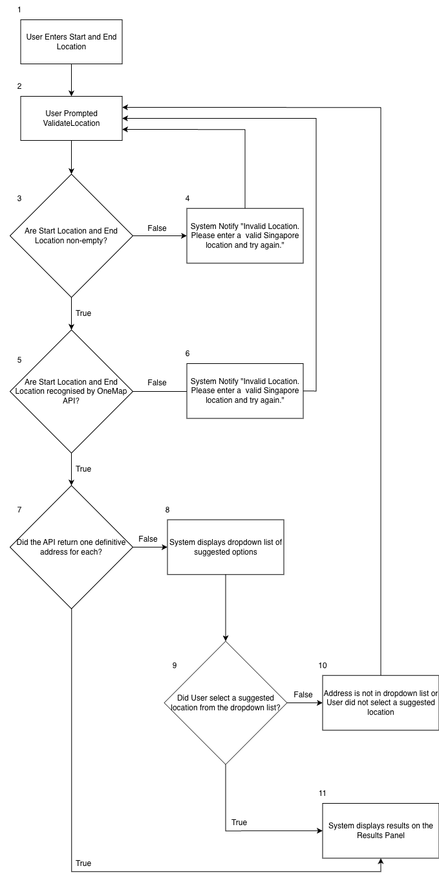

2.2 Basic Path Testing

Cyclomatic Complexity = | decision points | + 1 = 4 + 1 = 5

Basis paths

- Baseline Path 1: 1, 2, 3, 5, 7, 11
- Baseline Path 2: 1, 2, 3, 4, 2
- Baseline Path 3: 1, 2, 3, 5, 6, 2
- Baseline Path 4: 1, 2, 3, 5, 7, 8, 9, 11
- Baseline Path 5: 1, 2, 3, 5, 7, 8, 9, 10, 2

Explanation of basis paths

Path 1: User prompted to input start and end location. Start and end location are definitive addresses. The application will display the results on the Results Panel.

Path 2: User prompted to input start and end location. Start location is empty. User is prompted to input the address again.

Path 3. User prompted to input start and end location. Start location is not recognised by OneMap API. User is prompted to input the address again.

Path 4: User prompted to input start and end location. Start and End location are recognised by OneMap API but are not definitive addresses. Application displays a dropdown lis of suggested locations. User selects a suggested location from the dropdown list. System displays results on the Results Panel

Path 5: User prompted to input start and end location. Start and End location are recognised by OneMap API but are not definitive addresses. Application displays a dropdown list of suggested locations. User does not select a location from the suggested dropdown list. User is prompted to address again.

2.3 Test Cases and Results

Location(Start, End)
No. | Test Input | Expected Output | Actual Output | Pass?
1 | (Valid) Start Location : “50 Nanyang Ave, Singapore 639798”  (Valid) End Location : “ 301 Boon Lay Wy, Singapore 649846” | Location Validation  Successful | Location Validation  Successful | Yes
2 | (Valid) Start Location : “50 Nanyang Ave, Singapore 639798”  (Invalid) End Location : “ ” | System Notify “Invalid location. Please enter a valid Singapore location and try again.” | System Notify “Invalid location. Please enter a valid Singapore location and try again.” | Yes
3 | (Invalid) Start Location : “ ”  (Valid) End Location : “ 301 Boon Lay Wy, Singapore 649846” | System Notify “Invalid location. Please enter a valid Singapore location and try again.” | System Notify “Invalid location. Please enter a valid Singapore location and try again.” | Yes
4 | (Invalid) Start Location : “ ”  (Invalid) End Location : “ ” | System Notify “Invalid location. Please enter a valid Singapore location and try again.” | System Notify “Invalid location. Please enter a valid Singapore location and try again.” | Yes
5 | (Valid) Start Location : “50 Nanyang Ave, Singapore 639798”  (Invalid) End Location : “Ochard” | End Location = "Orchard Road”  Location Validation  Successful | End Location = "Orchard Road”  Location Validation  Successful | Yes
6 | (Invalid) Start Location : “Ochard”  (Valid) End Location : “ 301 Boon Lay Wy, Singapore 649846” | Start Location = "Orchard Road”  Location Validation  Successful | Start Location = "Orchard Road”  Location Validation  Successful | Yes

